PRINCESS ELLAINE P. AMPELOQUIO GNED 09

BSCS3A SIR. QUICHO

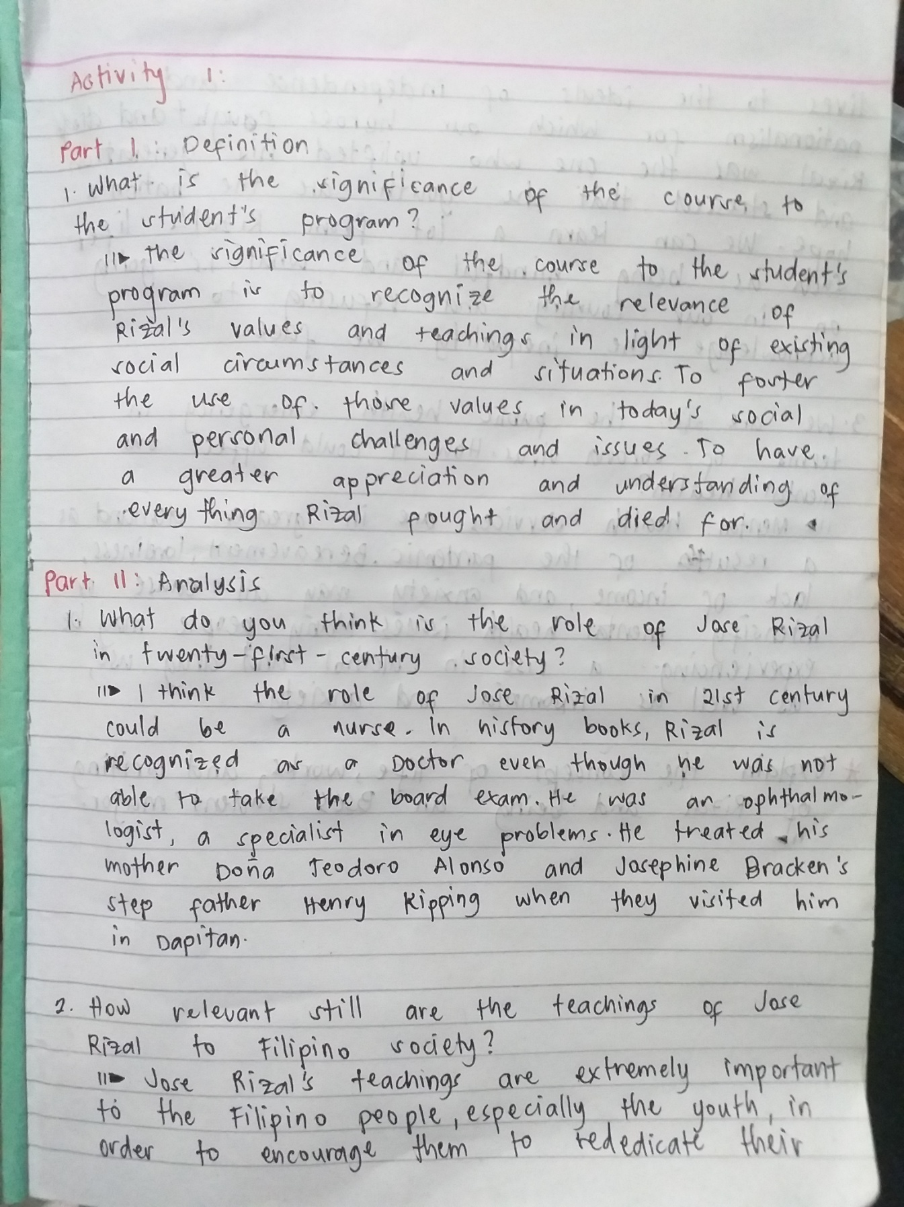**ACTIVITY 1**

